**Brooklyn torah gazette**

**For parshas haazinu 5783**

Volume 7, Issue 4 (Whole Number 311) 13 Tishrei 5783/ October 8, 2022

**Printed L’illuy nishmas Nechama bas R’ Noach, a”h**

For a free subscription, please forward your request to [***keren18@juno.com***](mailto:keren18@juno.com)

Past stories can be found on the website **ShabbosStories.com**

**Man Suffers Stroke, Saved**

**By Daf Yomi Chavrusa**

**By** [**David Israel**](https://www.jewishpress.com/author/di/)

[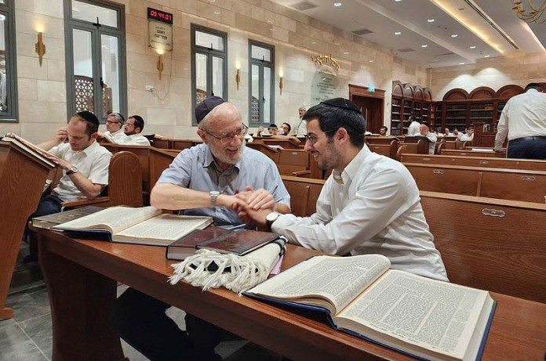](https://www.jewishpress.com/wp-content/uploads/2022/09/Shimon-Bach-and-his-study-partner.jpg)**Shimon Bach (R.) and his study partner.**

Earlier in September, a man suffered a stroke in his home in Petah Tikvah, and his family members called emergency services for help. Shimon Bach, a United Hatzalah volunteer EMT, was in shul for the morning prayers when he received the alert.

“As I was putting on my tefillin, I received an alert on my emergency communication device notifying me about a man who was suffering what they suspected was a stroke just a block away from my location. I grabbed my medical kit, ran outside, and rushed there. I arrived in less than 2 minutes.”

At which point Bach was startled when he discovered that his patient was also his study partner, with whom Bach learns every day.

“We study the Babylonian Talmud together as part of the Daf Yomi (the study of a daily page of the Talmud)” Bach explained.

Bach gave his chavrusa a quick and thorough check-up and found that he had all the signs of a stroke: his jaw was drooped, he couldn’t use his right hand, and he was unable to talk.

“He recognized me but couldn’t communicate,” Bach recalled. “I took his vital signs and waited with him until the ambulance arrived. When it did, I briefed the ambulance crew about his condition and helped put my friend and study partner into the ambulance. I wished him a full recovery and he was whisked away to the Rabin Medical Center in Petah Tikva.”

Just before Rosh Hashanah, Bach’s chavrusa was released from the hospital after fully recovering from the stroke. Bach met up with him, and they eventually sat down to continue their daily study.

“When I showed up, he was very moved and thanked me for being there to help him,” Bach said. “He invited me to a special thanksgiving meal for his recovery and hasn’t stopped thanking me since then. I am grateful to God that I was at the right place at the right time and that we have resumed our studying once more with a new sense of appreciation for each other, and for the time we have together.”

Tens of thousands of Jews worldwide study in the Daf Yomi program, and more than 300,000 participate in the Siyum HaShas, an event celebrating the culmination of the cycle of learning. The Daf Yomi program has been credited with making Talmud study accessible to Jews who are not necessarily Torah scholars and contributing to Jewish continuity after the Holocaust as a unifying factor among Jews. Each day of the calendar, including holidays and fast days, is included in the Daf Yomi schedule, with a plethora of online audio and video lectures available.

*Reprinted from the September 30, 2022 email of The Jewish Press.*

**How to Be a Good Guest**

**(And Host or Hostess)**

**By Tzippy Ayalona**

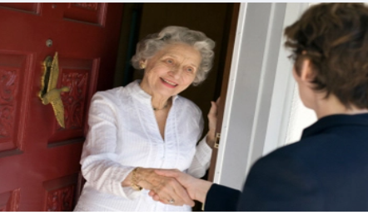

What a pleasure, what a relief, you think to yourself.  Your family has been invited out for a Shabbos meal.  No cooking, just enjoyment.  Or so you believe.  Naturally, there is the usual protocol and even duties of a guest:

*Be on time

*Bring a gift of appreciation

*Help serve the food, help cleaning off the table

*Be congenial,conversational

*Pay attention to hosts’ children

**But is there also a protocol for the responsibilities of the host?**

The answer is a resounding yes.  The obligation begins and ends with showing regard (respect if you will) for your honored guests.  It demands a sensitivity to the needs of your guests to feel comfortable in your home.  It requires a true sensitivity to Hachnasas Orchim.

    Under this category, let us examine the role that basic hygiene should play in and around the Shabbos Table:

    You are excited to receive your Shabbos or Yom Tov guests.  You have prepared a veritable feast and the Shabbos table is gleaming white and silver.  As an added touch, there is a stunning bouquet of flowers as a centerpiece.  The aromas cascading out of the kitchen, are simply tantalizing.  But that very same morning, your six- year-old, Shloime, comes down with a runny nose and a fever.  Surely, you will not insist your own child stay away from the Shabbos Table?  It’s nothing you haven’t dealt with before.  But, have you spoken to your guests about it?  Perhaps Reb  Goldberg has a special function to attend after the weekend?  Can he afford to be in such proximity to this virus?

    Miriam, too, has caught the nasty cold bug.  She is the one that helped prepare the salad. Naturally, you insisted she first wash her hands, but she was doing an impressive amount of coughing. Did you just place a stumbling block in front of your ‘blind’ guests?



    Moishe cut the melons for dessert.  Instead of cutting them on a proper cutting board, he did so on the kitchen counter, absently displacing a dirty dishrag. You noticed but chose not to make an “Inyan” of the matter.  Did you, in the end, shrug and tell Moishe to stick the fruit into the serving bowl and  then run and take a shower?  Chaim licked the cake frosting with his finger.  Did you take the initiative and simply straighten his artistic mess with a spatula and then put it out for the guests?

    Your husband, with or without a tickle in his throat, has recited a beautiful Kiddush.  He drinks from his Kiddush Cup and then proceeds to pour from the same into individual Kiddush glasses for attending guests.  Did your company sign up for this sharing of saliva?  Worse, your husband ,himself, is nursing a cold.  Over Hamotzi, he handles each individual slice of Challah, dipping  them into the salt.  It’s o.k. you think.  No one particularly cares.

    Miriam, the cold-ridden child who made the salad, also set the table.  The fact that she set the table  handling the forks and knives at the wrong end is over-looked in favor of  her volunteering to set the table in the first place.  Naturally, you could not possibly find the time to re-wash those germ-infested utensils:  What you can’t see, can’t hurt you, you reason.

    The meal proceeds smoothly.  All the delicacies are beautifully displayed on the table, the drinks are out and the conversation is flowing.  You feel a slight tickle in your nose followed by a series of sneezes.  What a lady, you quickly cover your mouth and nose with your hands, careful not to spread the germs. “Allergies”, you tactfully explain away. Still in the next instant your husband asks for the soda and you proceed to handle the bottle with the same germy fingers.  You are not through with  your sneezing and the next round, very ladylike, you use your napkin leaving it neatly bunched at the side of your plate.  Chances are, it will be picked up by someone else when it’s time to clear the table.



**Time for Dessert**

    Finally, it’s time for dessert.  The cake you have salvaged from Chaim’s artistic endeavor is served. The guests oooh and aah as you carefully serve individual slices onto the guest’s plates.  In between, with a look of contentment, you lick your fingers to remove traces of the chocolate frosting that managed to adhere to you skin.  Delicious for you, off putting to your guests.

    Coughing, sneezing, blowing one’s nose at the table are all habits that potentially sabotage your guests comfort level as air borne saliva finds its nesting place on the food served. (Note carefully if your children have been properly taught to turn away from the table, coughing and sneezing into the crooks of their arms.)

     Scratching one’s head, removing dirt from one’s eyes, picking at something stuck between one’s teeth, sticking a finger in one’s ear, wiping one’s nose with the back of a hand, or even picking one’s nose are all irksome, hygenic no-no’s that all too often share the Shabbos table along with good food, zemiras and the Shabbos bride.

**Time for Hygenic Sensitivity Towards Your Guests**

    Have we, in our zealousness of pursuing the mitzvah of Hachnasat Orchim, forgotten that it must be of a real benefit for the guest and not for yourself?  These scenarios, brutally depicted, regrettably, occur time and again, in countless religious homes, across social, ethnic and class divides.  While we are inarguably known as the People of the Book, some Frum families have seemingly turned the ‘page’ on basic hygiene principles. It’s time to re-examine the wider definition of Hachnasat Orchim to include hygenic sensitivity towards your guests.

    While it is perhaps gratuitous to post signs on our doors:  Enter at your own risk or peril, it is not superfluous to hold hygiene related discussions with all members of your family before you further undertake this very important Mitzvah.  In light of flu seaon and just in general let us be mindful of:

Derech Eretz kadmah l’Torah

Basic Hygiene before Hachnasas Orchim

May we all be zocheh to be wonderful hosts and comfortable guests.  Shabbat Shalom

*Reprinted from VinNews.com*

**Shabbos Candle Lighting**

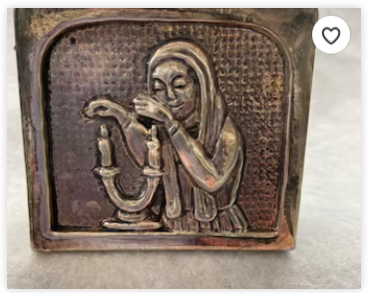

*Reprinted from Davidsolomon Judaica*

**Looking for Jews in the**

**Most Unlikely Places**

**By Daniel Keren**

(“The Prophet of the Andes: An Unlikely Journey to the Promised Land by Graciela Mochkofsky, translated by Lisa Dillman, 269 pages, Alfred A. Knopf, New York, 2022)

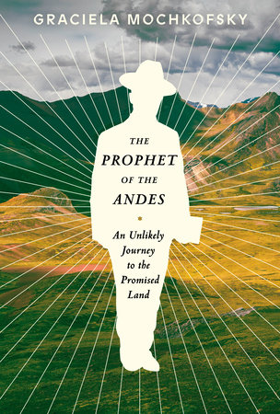 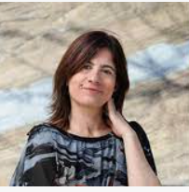

**Graciela Mochkofsky, author of the “Prophet of the Andes”**

Graciela Mochkofsky, the daughter of an atheist father descended from Ashkenazi (Eastern European Jews) and a devout Paraguayan Catholic mother, has written an intriguing book – “The Prophet of the Andes: An Unlikely Journey to the Promised Land.”

The “Prophet” was an unusual mestizo (a Latin American term for a man or woman of mixed race, specifically one having a combined Spanish and indigenous descent) originally born in 1927 in the poor Andes town of Rodacoha in Peru as a believing Catholic. At the age of 17 Segundo Villanueva’s father who tended a small potato patch was murdered by a neighbor over a monetary dispute. Originally committed to avenging his father’s death, Segundo opened his father’s trunk and discovered a Spanish translation of the Bible by a Protestant printing house. As he began reading the Bible, which at that time the Catholic Church discouraged its followers from reading, a new spiritual journey began for him that would affect hundreds of other mestizos in Peru and elsewhere throughout South America.

**Tracing the Vinnanueva Family**

**To a Spanish-born Adventurer**

Ms. Mochkofsky traces the Villanueva family with the help of Catholic Church baptistry records to the final days of the 16th Century when the Spanish born adventurer - Cristobal Fernandez Nieto de Villanueva came to Cajamarca, Peru in hopes of finding a fortune.

At the beginning of “The Prophet of the Andes”, Ms. Mochkofsky who on her own soured on Catholicsim as a result of having been enrolled by her mother in a Catholic school run by nuns that promised her that her “Jewish” father couldn’t go to heaven because he wasn’t baptized, gives a historic portrait of how the Spanish conquistadores led by Francisco Pizarro (1478-1541) on behalf of the Spanish monarchy and the “Holy” Catholic Church destroyed the indigenous culture and society, beginning with the Battle or Massacre of Cajamarca that marked the defeat of the Inca Empire.

Despite Pizarro’s promise to spare the life of the Inca Emperor Atahualpa if he gave the Spanish a room filled with gold and two other rooms filled with silver was not honored.

**Embarking on an Amazing Spiritual Journey**

Returning to Segundo Villanueva, as mentioned before he embarked on an amazing spiritual journey with the discovery of his murdered father’s Spanish language Bible. He becomes disturbed by the significent contradictions in the New Testament, but more importantly by the concept of Shabbat.

Segundo becomes fascinated by the concept of Shabbat and can’t find anything in the Bible (especially the New Testament) that justifies Catholics and other Christian sects making Sunday their holy day and thereby desecrating the holy Shabbat day. For the next three and a half decades, Segundo began studying the Bible with hundreds of his neighbors in Cajamarca, Peru where he made his livlihood as a carpenter.

Gradually he and his followers abandoned Catholicsim and briefly attempted Seventh Day Adventism theology before discovering a Jewish Spanish translation of the Tanach and other Jewish books including an abbreviated Spanish translation of the Shulchan Aruch (Code of Jewish Laws) that ignited the realization in their hearts that the true religion was Judaism and that this was the only way that they could connect with G-d. As a result the men paid a Jewish doctor to circumcise them as commanded in Tanach.

**Flown to New Homes in Elon Moreh, Israel**

After many efforts by members of the new spiritual community, the Israeli Chief Rabbinate office in 1988 agreed to send rabbis to inspect the community. After testing those in Peru who wanted to convert, more than 100 were approved and after their conversion were flown to Israel and settled in Elon Moreh, a religious community in the West Bank (Shomrom and Yehuda) where they were given homes that for the first time afforded these former mestizos with electricity, running water and other amenities that we in the developed world take for granted.

In writing back to their families and friends back in Peru, their letters describing their new first world lifestyle and this triggered a greater desire for their aquaintences to also convert to Judaism, and as Ms. Mochkofsky explains many of that second wave desiring to become Jewish was perhaps not truly spiritually sincere. As a result the Chief Rabbinate Office in Jerusalem has suspended further conversions in Peru.

**A Sad Turn of Events**

Israel Segundo who upon conversion to Judaism took the name of Zerubbabel Tzidkiya sadly reverted from true Judaism and rejected the Oral Torah and even dabbled with theological conversations with the Samarite and Kararite sommunites in Israel.

Yet, for most of those Jews who came from Peru with Segundo, their immigration was highly successful and they have integrated into Israeli socieities, serving in the army and having children and grandchildren who have married native born Jews with no distinctions. Those grandchildren don’t speak Spanish, but rather Hebrew.

While I don’t agree with all of Ms.Mochkofsky’s take on Judaism or Israeli history or current events, I find her explanation of the unlikely journey of a most fascinating spiritual mestizo community to the Promised Land a valuable read.

*Reprinted from this week’s edition of the Jewish Connection.*

**Rav Avigdor Miller on**

**How to Make Aliyah**



**QUESTION: What is your attitude to us settling in Eretz Yisroel?**

**ANSWER:** And the answer is, it depends. If you are influenced by the Zionists, then you have to know you are a victim of propaganda. If you are doing it because of daas Torah it’s a different story but I want to tell you, very few people settle in Eretz Yisroel because of daas Torah. Actually, it is a form of patriotism engendered by the non-religious groups.

Now, I will explain it to you. If you want to better your ruchniyus, you want to learn more Torah, you want your children to be better Jews, and that is why you are going, then I’m all for it. But first the question is, is it so? Is it the very best place for children to grow up in the Torah way? If after investigating it thoroughly you discover that is the case, then certainly, there’s no question.

For some people, however, it is definitely not so. Some people will find their success not in Eretz Yisroel; they will learn and they will make progress in Torah and mitzvos – and their children too – elsewhere.

And therefore, it depends what’s your purpose. A Rosh Yeshiva once told me, “Just to go to Eretz Yisroel without having a specific place in mind where you want to settle is like to going to Chicago.” Because there is a Chicago in Eretz Yisroel too. You want to settle in Tel-Aviv?! And therefore, it depends where you are going.

Now, they’ll tell you maamarei chazal – if you walk four amos in Eretz Yisroel then it is better than anything else in chutz laaretz. Don’t misunderstand these things; our sages themselves remained in chutz laaretz because they had good reasons to be there. Ezra refused to go to Eretz Yisrael כל זמן שברוך בן נריה קיים. As long as his rebbe was alive he wouldn’t budge. Now, that’s a consideration. In Eretz Yisroel they were building the second Bais Hamikdash and Ezra didn’t come because his rebbe was still in Bavel and he needed his rebbe; as long as his rebbe was alive he wouldn’t budge. So you see there are other considerations that take precedence.

And you have to know why do you want to go? Is it just because of a Zionist dream? Then it’s a false dream, and who knows what is going to happen. You think it’s going to be forever the Jewish state? You don’t know what is going to happen. The little state there is wobbling. Who said there is security there? Who said you are safe there? And therefore, if you go because you want ruchniyus so you disregard other considerations; but other-wise you’re just a victim of propaganda.

*Reprinted from the September 19, 2022 email of Toras Avigdor (Tape #408 – June 1982).*

**Rabbi Berel Wein**

**On Parshas Haazinu**

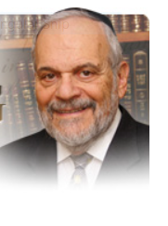

The special nature and all of the events of Jewish history are outlined for us in this week’s parsha. Ramban in the 13th century comments that anyone who can, so many centuries earlier, accurately foretell the later fate of a people is an exceptional prophet. Moshe certainly fits that description and test. And what more can we add to this phenomenon, now seven hundred-fifty years after Ramban!

The rabbis of the Talmud attributed the crown of wisdom to the one who has a vision of the future. Even though Moshe is the greatest of all prophets, his title amongst the Jewish people is Moshe the teacher, indicating his wisdom and knowledge are translated into his ability to view the future.

Moshe lays down the basic pattern of all of Jewish history – the struggle to remain Jewish and not succumb to the blandishments of current cultures and beliefs, the illogical and almost pathological enmity of the world to Judaism and the Jewish people, the awful price paid by Jews throughout history and the eventual realization of Jews, and the non-Jewish world as well, of God’s guidance in history and human life.

This entire, very complex story is foretold to us in this week’s most remarkable parsha. It is no wonder that Jewish tradition dictated that Jewish children should commit this parsha to memory, for within it is recorded the entire essence of Jewish history.

Though we never really know the exact details of the future of the Jewish people, the broad outlines of the story have been known to us for millennia. Just read and study the words of this parsha.

Moshe establishes heaven and earth as witnesses to the covenant and the historical fate of the Jewish people. Rashi explains that not only are they honest and objective witnesses but most importantly they are eternal witnesses. Human witnesses are mortal and passing. Later generations cannot hear their testimony, and even though current video technology attempts to correct this deficiency, much of the personal nuance and force, which colors all human testimony, is lost.

So we rely on heaven and earth to reinforce our belief and commitment to the eternal covenant. It is the very wonders and mysteries of nature itself that point to the Creator. And it is all of human history that rises to testify as to the uniqueness of the Jewish story and the special role that the Jewish people played and continue to play in human events.

The witness testimony of heaven is found in the wonders of the natural world. The witness testimony of earth is found in the history of humankind and of the role of the Jewish people in that amazing, exhilarating and yet depressing story. Moshe begs of us to listen to these two witnesses for it is within their and our ability to know our past and future through their testimony.

Much of their testimony is frightening and worrisome but it is even more frightening to be unaware of our past and future. We should listen carefully to the parsha. It has much to teach us about our world and ourselves.

Shabat shalom.

*Reprint from this week’ website of rabbiwein.com*